The Ant Simulator Project

Software Requirements Specification

Version 1.0

Revision History

n/a

Table of Contents

Introduction 4

Purpose 4

Scope 4

Definitions, Acronyms, and Abbreviations 4

References 4

Overview 5

Overall Description 5

Product perspective 6

user characteristics 6

constraints 6

assumptions and dependencies 7

Specific Requirements 7

Functionality 7

Menu 7

Credits 7

Settings 7

Resume / End Game 8

Usability 8

Download 8

Controls 8

Reliability 8

Availability 8

Bugs 8

Performance 8

Supportability 9

Coding Standards 9

Naming conventions 9

Libraries 9

Design Constraints 9

On-line User Documentation and Help System Requirements 9

Purchased Components 9

Interfaces 10

User Interfaces 10

Hardware Interfaces 10

Software Interfaces 10

Communications Interfaces 10

Licensing Requirements 10

Legal, Copyright, and Other Notices 10

Applicable Standards 10

Supporting Information 10

Table of Figures 10

Software Requirements Specification

# Introduction

## Purpose

The purpose of the Software Requirement Specification is to explain the use and functionalities of the application, as well as giving an insight in design, structure and requirements of the final application.

Please note that this document is not finalized and will be updated in the progress of development!

## Scope

This document describes the interaction between the player and the Ant Simulator Project (TASP) and its behavior. TASP is a 2D-Simulator Game based on Unity. The player can grow, defend and command his own ant colony, while the AI is growing its own colony and will try to attack yours occasionally.

The different subsystems are: Menu and Game, which includes the Level Design.

## Definitions, Acronyms, and Abbreviations

|  |  |
| --- | --- |
| Acronym / Abbreviation | Definition |
| TASP | The Ant Simulator Project |
| UML | Unified Modeling Language |
| AI | Artificial Intelligence |
| RTS | Real Time Strategy |

## References

|  |  |
| --- | --- |
| Blog | <https://antsimulator.wordpress.com/> |
| Use Case Model | <https://github.com/TheKleopiNetwork/antSimulator/blob/master/Use-Case%20Model%20SRS%20(TASP).docx> |
| GitHub | <https://github.com/TheKleopiNetwork/antSimulator> |

## Overview

This document will give an overview about the project, its functionality, performance and how to use it.

# Overall Description

The final game will be available as an executable which can be entered by double-click as usual. It will be compatible with Windows, Mac and Linux systems.

## Product perspective

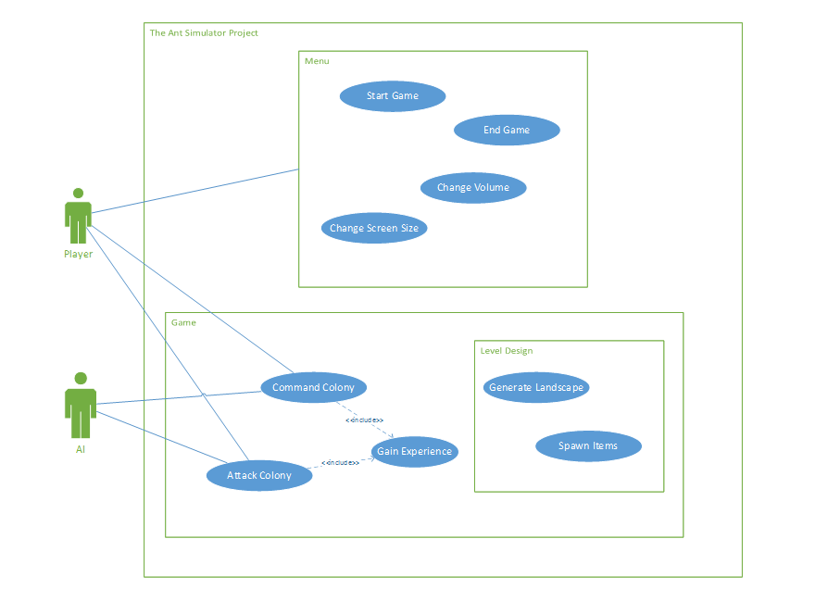

Figure 1: UML Model

## user characteristics

The user needs a computer as well as a keyboard and a mouse. He or She should like RTS-games or simulators, because TASP consists of elements of both.

## constraints

n/a

## assumptions and dependencies

To successfully implement TASP the following dependencies / assumptions will be important:

|  |  |
| --- | --- |
| IDE | Unity |
| Version-Control | GitHub |
| Programming Language | C# |
| Modeling | Blender |
| Misc. | WordPress, FL Studio, MS Project |

# Specific Requirements

## Functionality

### Menu

The Menu will appear first when starting the application and can be opened with Esc while playing. It consists of buttons to start the game or rather resume the game, change settings, end the game and credits.

### Credits

The Credits will show the team who developed the game, as well as further information to the game.

### Settings

The Settings allow the user to adjust the volume and change the screen resolution or rather the screen size. There will also be the option to change between the available languages.

### Resume / End Game

The resume and end button will resume the application or lead the user back to the desktop. While in the menu, the game will be paused.

## Usability

### Download

The user only must download the file (and unpack it). Afterwards it is accessible by double-clicking the game icon.

### Controls

Without a working keyboard, mouse and screen, the user won’t be able to play/enjoy the game.

## Reliability

### Availability

The game will be downloadable on our GitHub-Page for free. When the game crashes or files are lost which leads to errors, you can just download the game again.

### Bugs

There are no bugs known so far. If you notice any inconsistencies, please contact us via mail or leave a comment on our GitHub-Page or our WordPress-Blog.

## Performance

Since we don’t know how much hardware capacity we will need to play the game effortlessly, we can only guess hardware requirements. The game itself will be low poly, while the models will be created in high poly condition.

## Supportability

To be done

## Design Constraints

n/a

## On-line User Documentation and Help System Requirements

A tutorial guide or short tutorial document will be placed in the game menu or the game register.

## Purchased Components

n/a

## Interfaces

### User Interfaces

The user will be led directly to the main menu when starting the application. There he can either start the game, read the tutorial, change the game settings or leave the game.

### Hardware Interfaces

There won’t be any Hardware Interfaces.

### Software Interfaces

n/a

### Communications Interfaces

Keyboard, Mouse, Screen, (Local Area Networks)

## Licensing Requirements

## Legal, Copyright, and Other Notices

## Applicable Standards

# Supporting Information

### Table of Figures

Figure 1: UML Model 1